**Flight Price Prediction using Machine Learning**

**Introduction:**

This is a blog on the title “Flight ticket price prediction”, a project on machine learning which we will be doing in python. We will go through the entire steps for building a machine learning model that can be used to predict the flight ticket price and we will be understanding them thoroughly. The topics that we are going to cover are:

* Problem Definition
* Data Analysis
* EDA Concluding Remarks
* Pre-Processing Pipeline
* Building Machine Learning models
* Concluding Remarks

**Problem Definition:**

Nowadays more and more people are choosing flight as a travel option, and as the majority of the population in the nation are from middle income household, price of the flights play an important part in choosing a flight for travel. But it may be difficult for a person to know the exact price of the tickets as the price of the flights keeps on fluctuating and is very difficult to predict. Here, machine learning comes into play. By using the price and other data of the previous flights that have operated earlier, we can create a model that can predict the price of the tickets for the upcoming flights.

**Data Analysis:**

In this project, we are provided with prices of flight tickets for various airlines between the months of March and June of 2019 and between various cities. Also we are provided with two datasets- Train data and Test data. At first we import all the required libraries that we will be needing and then load the datasets into the notebook.

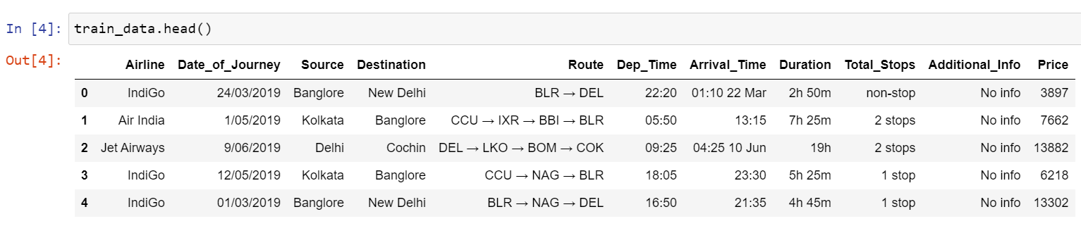

Screenshot of the train dataset

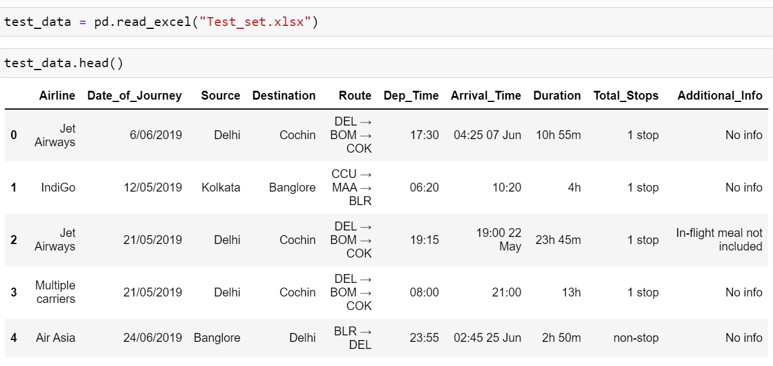

Screenshot of the test dataset

Both the datasets are similar, with the Test data not having the ‘price’ column. Using the Train dataset we have to train and validate our model, and using that model we have to predict the price in the test dataset. The features that are present in the datasets are:

**Airline**: The name of the airline.

**Date_of_Journey**: The date of the journey

**Source**: The source from which the service begins.

**Destination**: The destination where the service ends.

**Route**: The route taken by the flight to reach the destination.

**Dep_Time**: The time when the journey starts from the source.

**Arrival_Time**: Time of arrival at the destination.

**Duration**: Total duration of the flight.

**Total_Stops**: Total stops between the source and destination.

**Additional_Info**: Additional information about the flight

**Price**: The price of the ticket

The price column is the target column here.

**EDA Concluding Remarks:**

First of all we check the shape of the dataset to get an idea about the size of the data. Then we check for any missing values in the dataset, so that we can treat them.

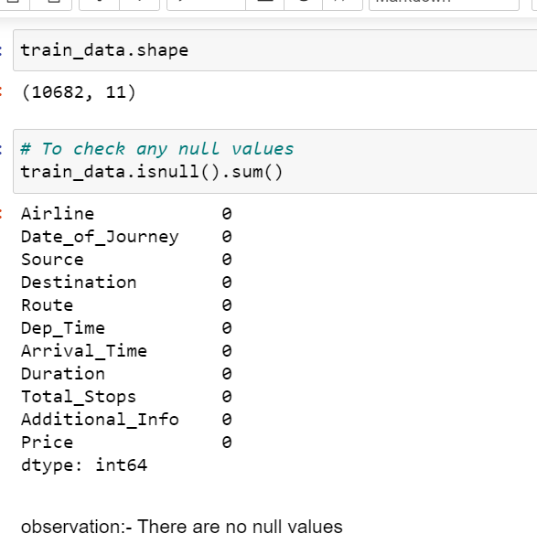

We have found the shape of the train data to be of 11 columns and 10682 rows. Also we have found no missing values in the train data .

We checked the information of all columns

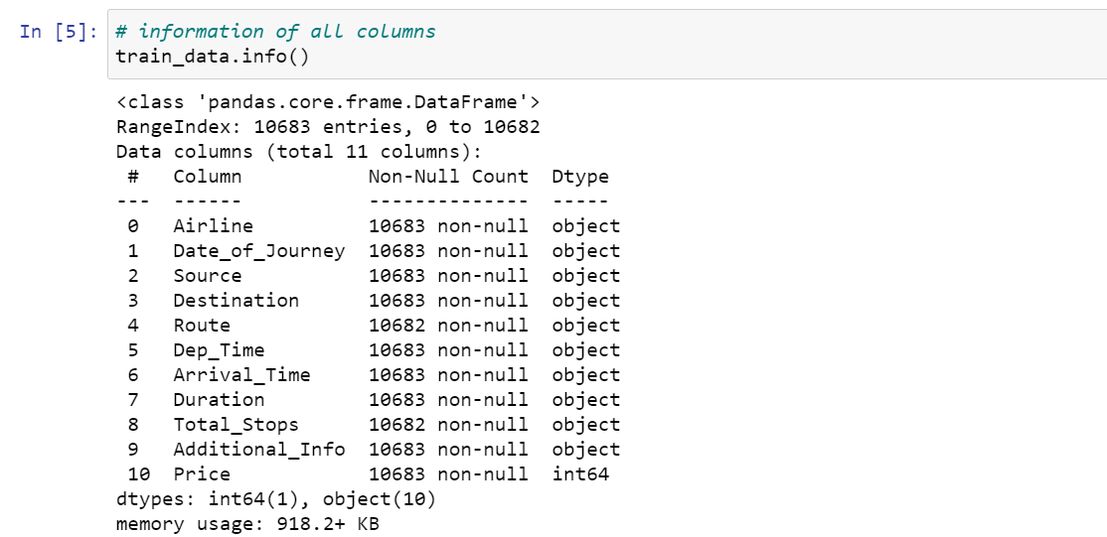

By observing there are 9 objects and 1 numerical data

Analyzing the unique values we found many columns containing date and time in the records, we need to treat them, we also found some of the columns being categorical in nature. We then check the value counts of certain columns.

As journey_day column is in day,month,year but model didnot recognize this format so by to_datetime method we are parsing the format into day as dt.day,and month as dt.month



We now perform feature engineering on the features in the dataset. As we saw the features “Date of journey”, ”Dep time” and “Arrival time” contain date and time in the data, we need to treat these columns and extract the info from them.

Screenshot of the code

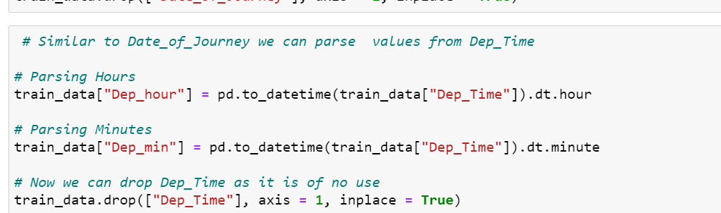

**Handling Categorical Data**

One can find many ways to handle categorical data. Some of them categorical data are,

**Nominal data** --> data are not in any order --> **OneHotEncoder** is used in this case

**Ordinal data** --> data are in order --> **LabelEncoder** is used in this case

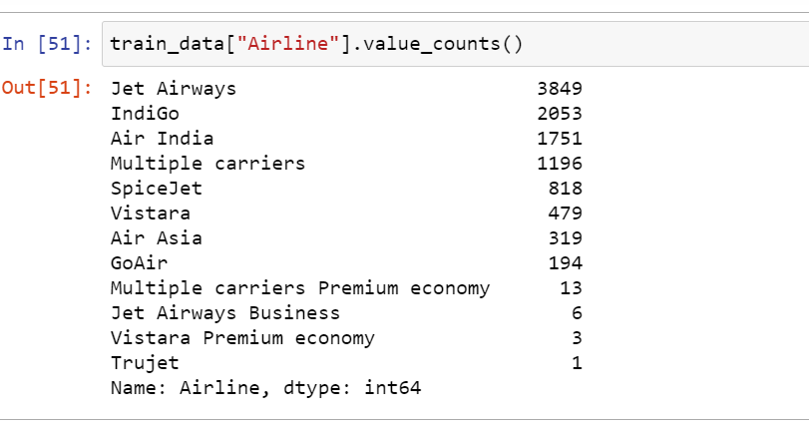

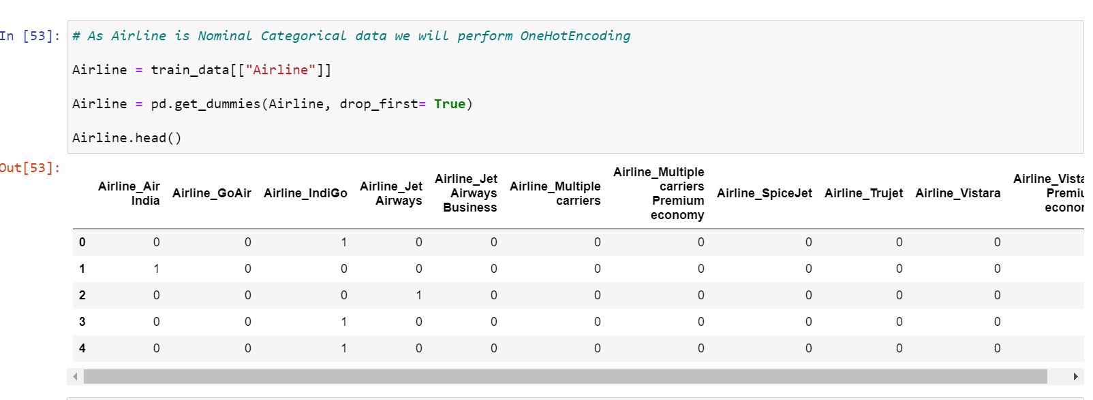

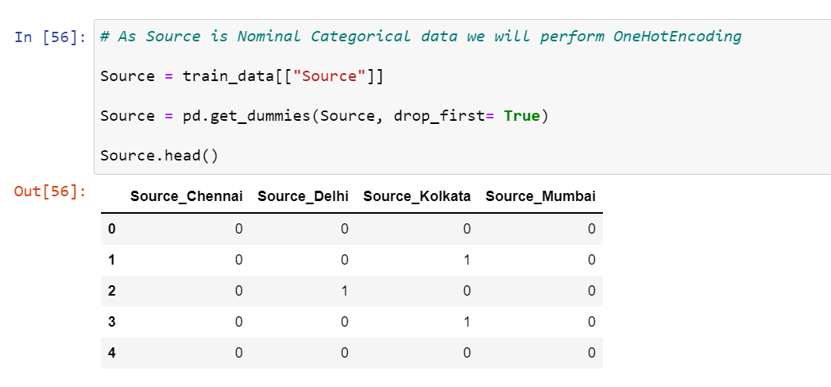

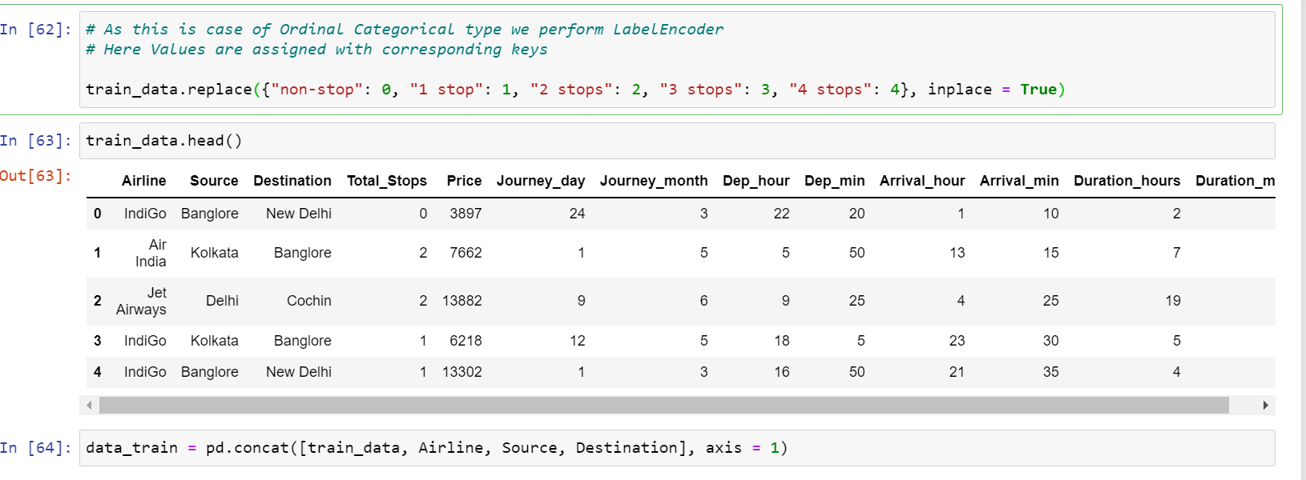

**Date of journey:**

* We first convert the object data type of the column to date and time.
* Then we extract the day and month from the data and store it in separate columns.
* And then we drop the base column, as we no longer need it.

**Dep Time:**

* First we convert the object data type to date and time.
* Then we extract the hour and minute from the column and store it in separate columns.
* And then we drop the base column, as we no longer need it.

Arrival Time:

We follow the same steps as done for “Dep Time” and extract the arrival hour and arrival minute from the data.

**Duration:**

The column contains the duration of the flight in, but is contains string in it. So we try a different approach here.

* We first create a list and store the column data in it.
* Then we add ‘0 m’ or ‘0h’ in the records that contain only the hour or the minute respectively.
* We then add the list to the dataframe.
* After this we split the data in the column, keeping the hour and minute without any string in different columns.
* We drop all the unwanted columns created in this process along with the base column.
* Finally we convert the two final columns into integer.

After the feature engineering, we visualized the distribution of the data in different columns using different plots and then checked the correlation between the columns.

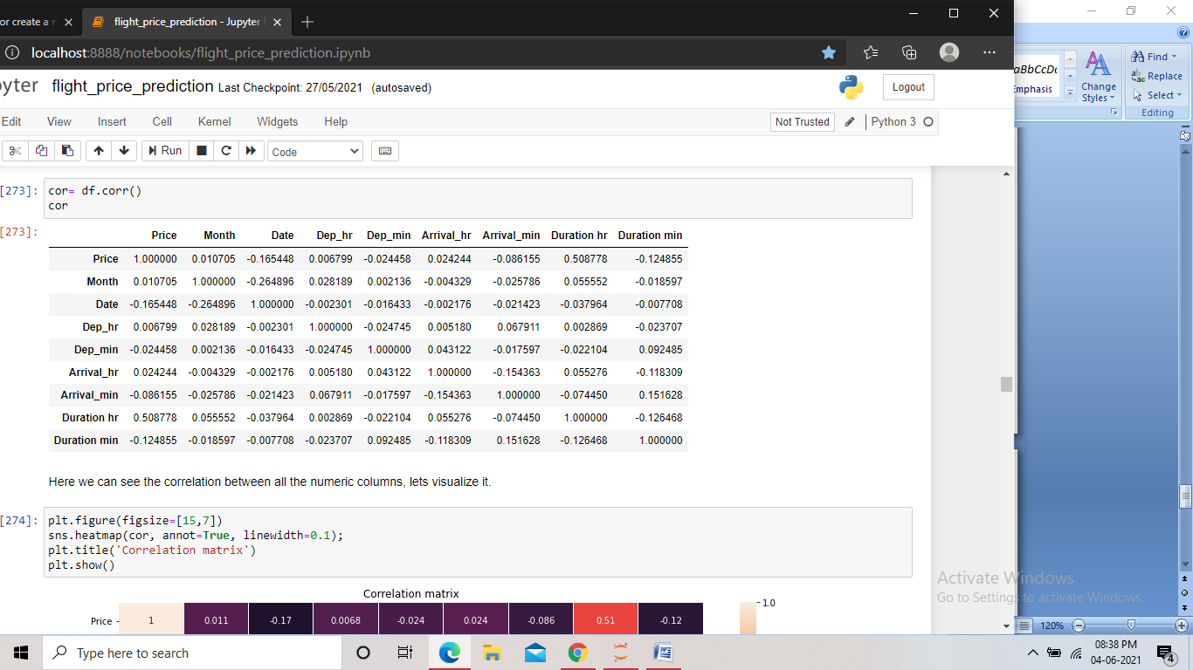

Screenshot of the code

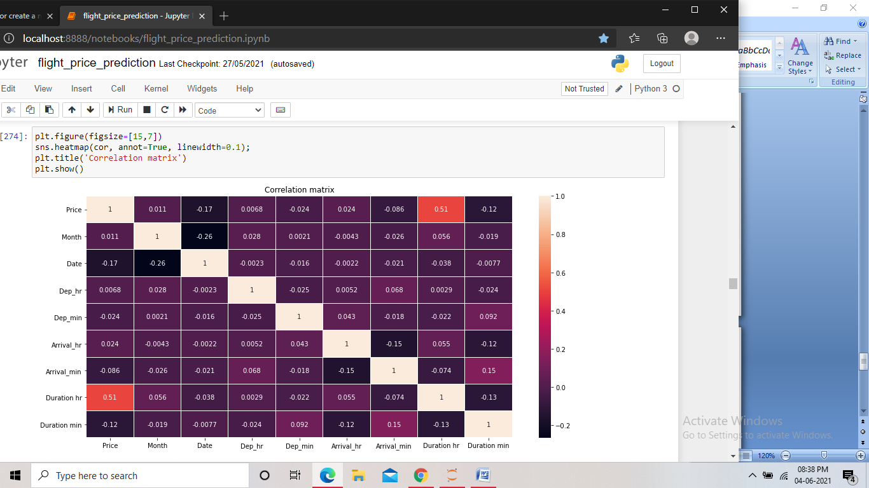

Screenshot of the code

We then perform Bi-variate and Multi-variate analysis on the dataset and get a better understanding of the correlation among different columns, mainly with the target column.

After this, we perform encoding on the dataset as there were still some columns left with object datatypes. The columns left were categorical in nature. For the columns having nominal data we performed one-hot encoding as the number of categories were also less.

And for the ordinal data column, we performed Label encoding.

In the dataset we are not checking for the outliers or skewness, as the dataset mostly contains date and time as data, and the rest of the data are categorical in nature.

The pre-processing of the train data is done, now we pre-process the test data using the same steps used for the train data. We can Pre-Process both the datasets together by appending them at the start, but we did not do that. This is because if we pre-process the train and test data together, it can **cause data leakage which can then lead to overfitting problem during the model building.**

**Building Machine Learning models:**

At first we split the train data into target and features.

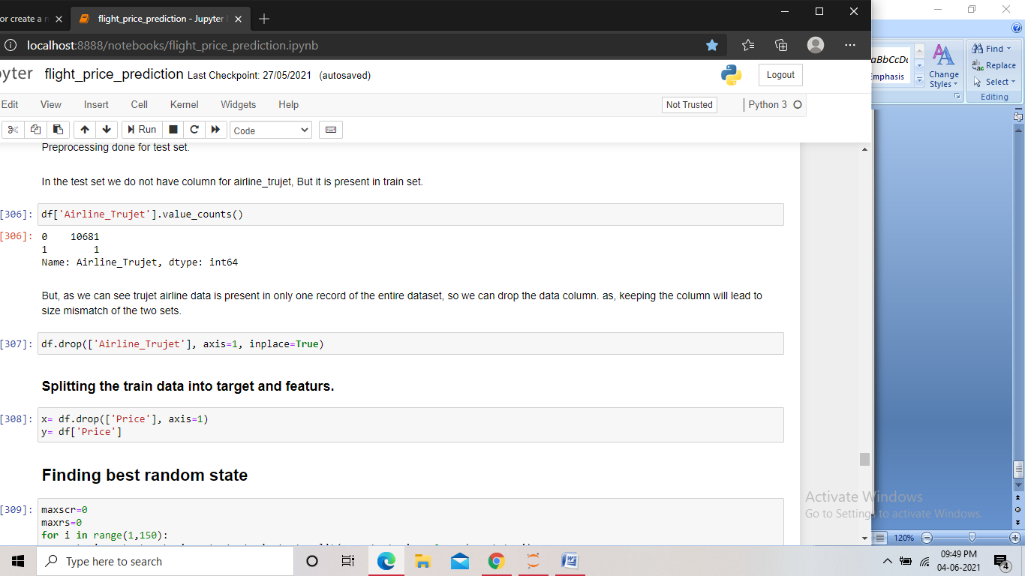

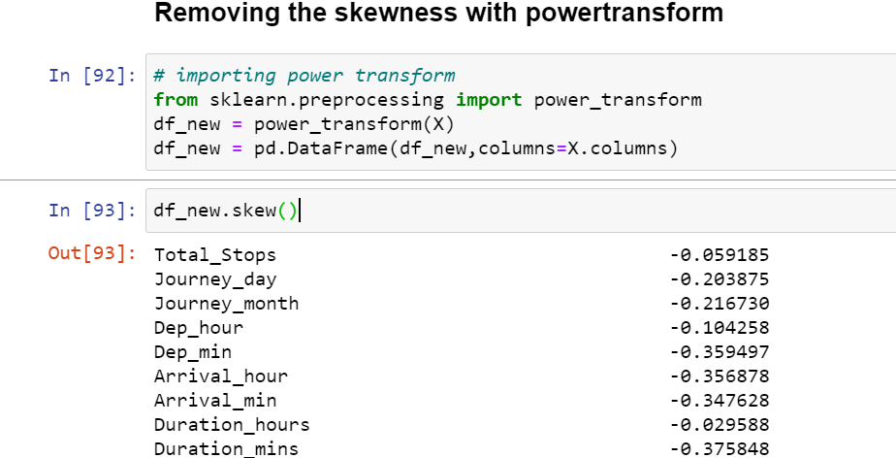

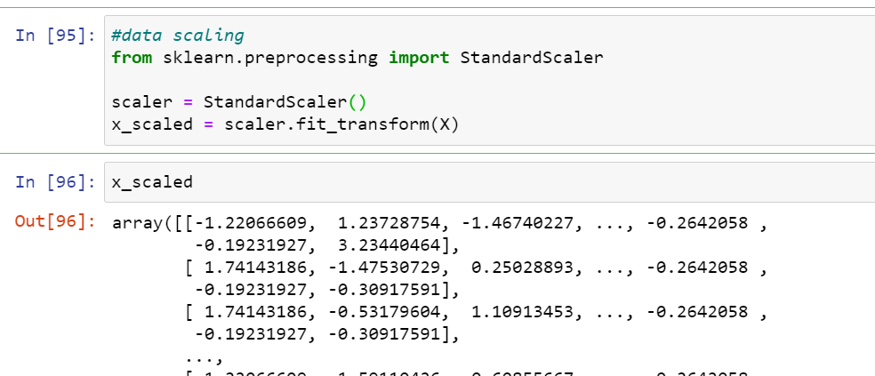

Now, we scaled the x values with standardscaler, we split the data for the training and the validation, keeping the training size to 75%.

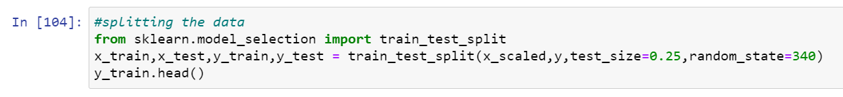

We then import different models and fit those models using the train splits. And after this, we send the x-validation split to the models for prediction. The predictions that we get are then compared with the actual targets and we get the r2 score of the model. We also get the training score by comparing the two train splits. Also, taking the prediction that we got using the model and the actual target, we find the mean absolute error, mean squared error and the root mean squared error. We then print all the scores and the errors.

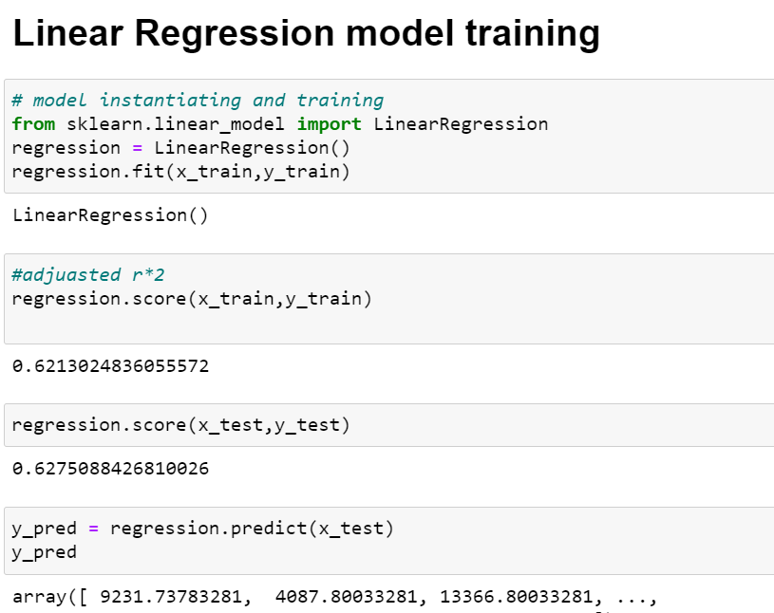

Screenshot of the code for linear regression

For linear regression, we found the r2_score of 62.75%.

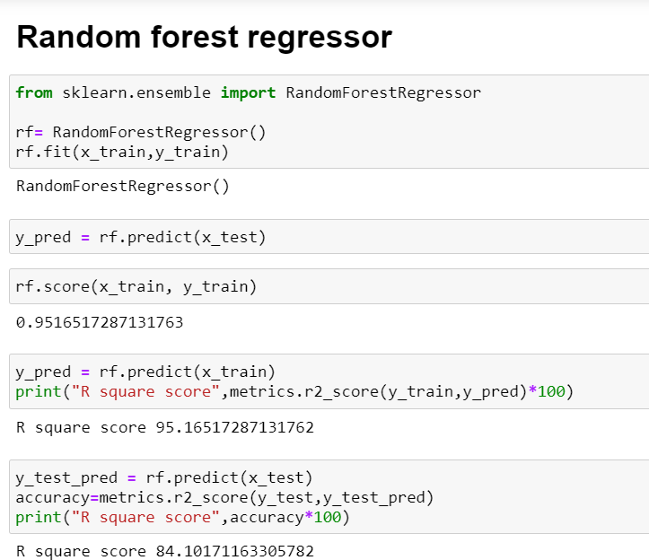

Screenshot of the code Random forest regressor

Using Random forest regressor, we found the training score to be 95% and the r2_score of 84%.

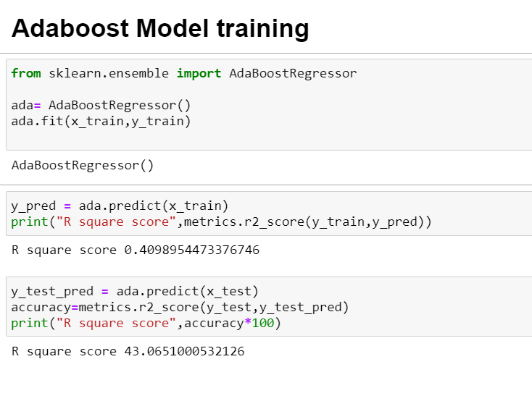

Screenshot of the code for Adaboost regressor

Using Adaboost regressor, we found a training score of 40% and the r2_score of 43%

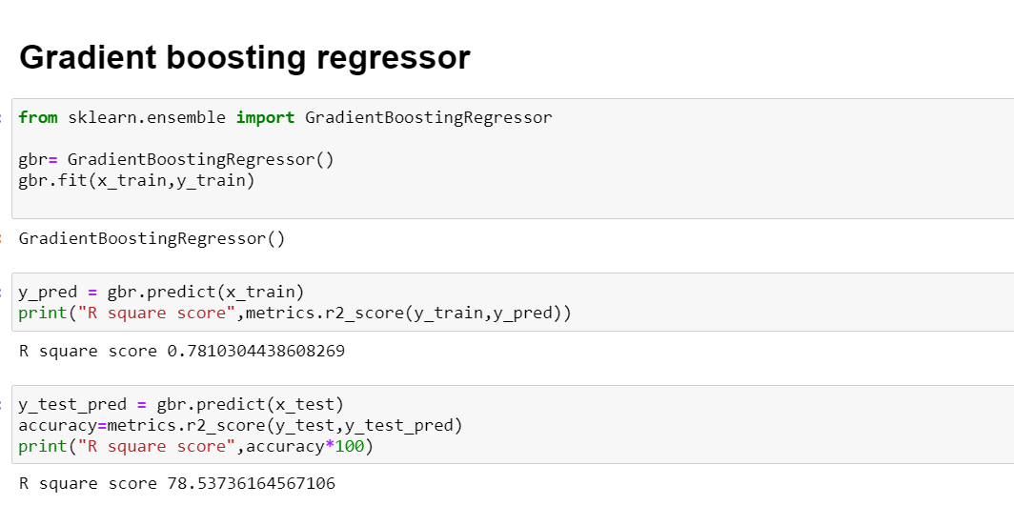

Screenshot of the code Gradient boosting regressor

Using Gradient boosting regressor, we found the training score to be 78% and the r2_score of 78%.

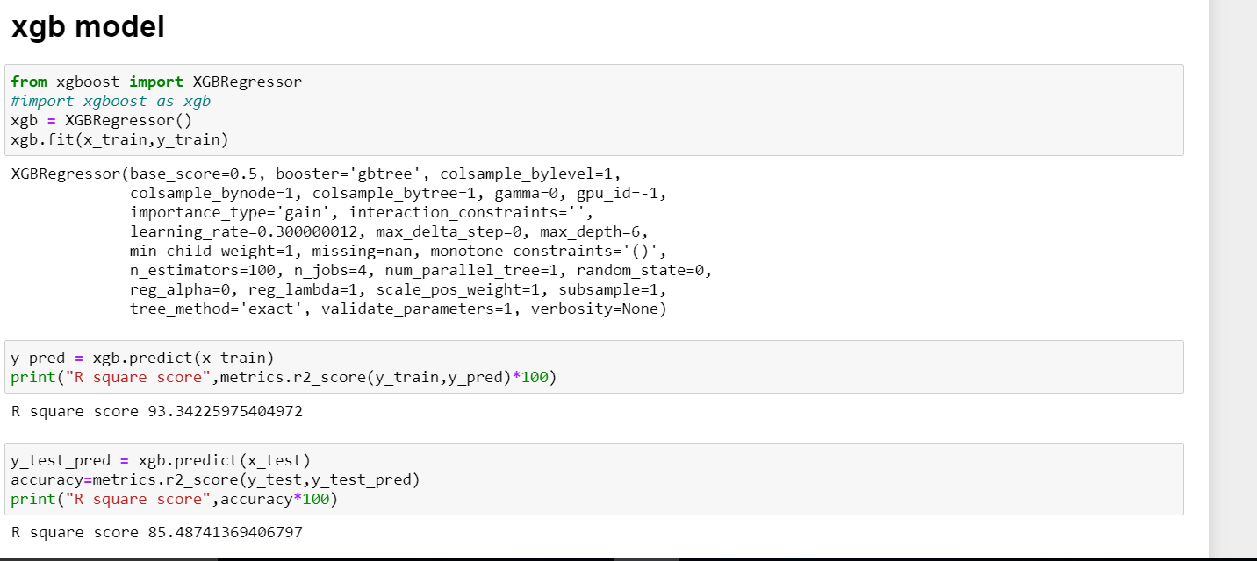

Screenshot of the code for XGBoost regressor

Using XGB regressor, we found the training score to be 93% and the r2_score of 85%.

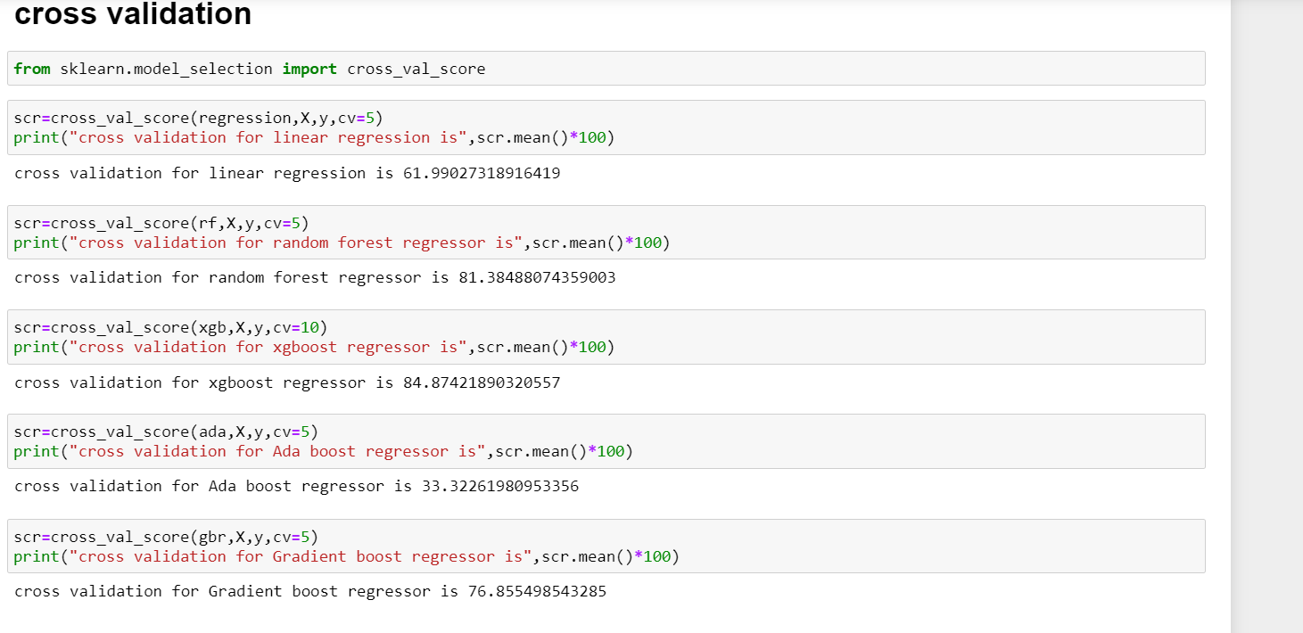

Screenshot of the code

## By observing crossvalidation scores with different models Randomforest model shows least difference

.

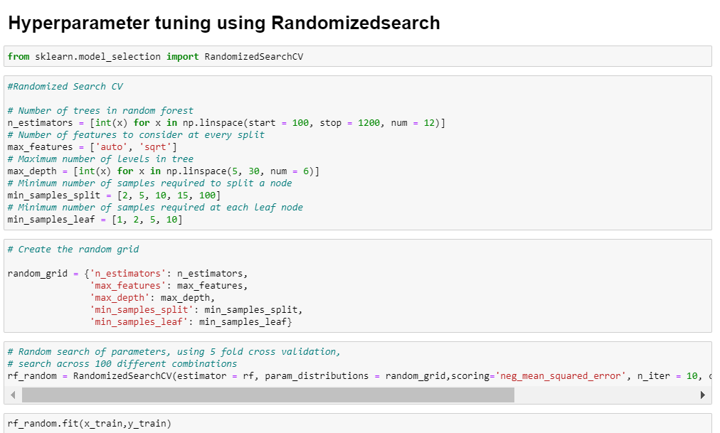

Screenshot of the code for hyper parameter tuning Random forest model

We used RandomizedSearchCV to find the best parameters for the model. And then using the parameters found to be best, we created our model. We found r2 score 85%.

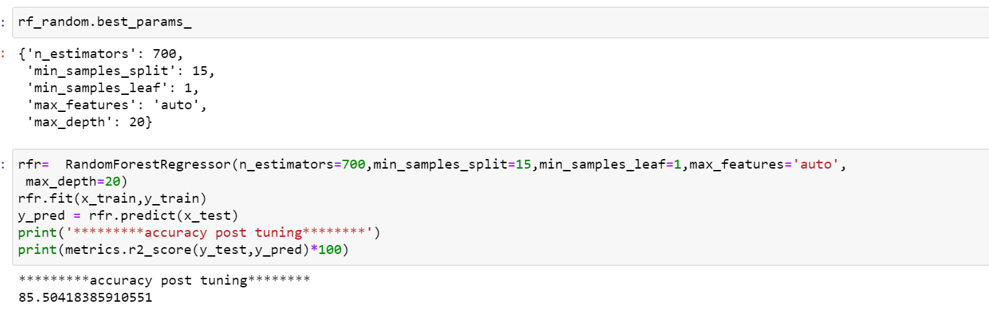

. We then loaded the saved model into a variable. And using that model we predicted the price for the test dataset. Which is then stored in a dataframe for submission.

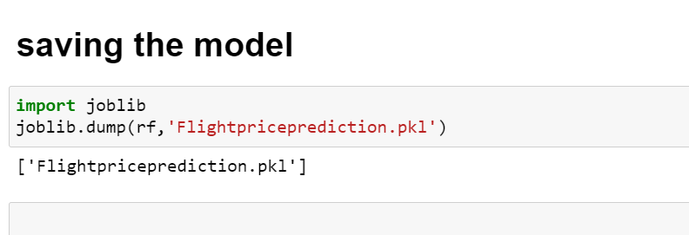

**Concluding Remarks:**

In this project we found the feature engineering play a crucial role in the performance of the model. We treated columns containing date and time data and categorical data.

While performing Bi-variate analysis we found the Duration of the flight being very positively correlated with the price, we also found jet airways business flight being the most expensive among all, with spicejet being the least expensive. Also we found that as the number of stops increases the price of the flights also increases.

With this project we also got an idea about pre processing the train data and test data separately and different encoding techniques to be used for different types of data. We Also saw how we can check different model’s performances, and to select and finalize the best performing model.